**M.Sc. (Five Year Integrated) in Computer Science**

**(Artificial Intelligence & Data Science)**

**Semester 3**

**Database Systems Lab**

**LAB CYCLE 1**

Consider following databases and Draw ER diagram and convert entities and relationships to relation table for a given scenario.

COMPANY DATABASE:

EMPLOYEE (*SSN, Name, Address, Sex, Salary, SuperSSN, DNo*)

DEPARTMENT (*DNo, DName, MgrSSN, MgrStartDate*)

DLOCATION (*DNo,DLoc*)

PROJECT (*PNo, PName, PLocation, DNo*)

WORKS_ON (*SSN, PNo, Hours*)

E-R Diagram

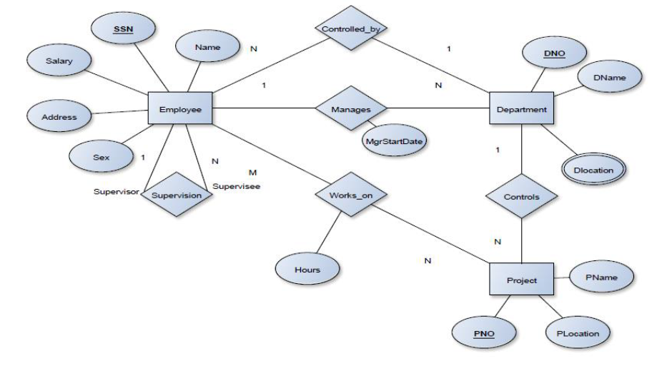

Schema Diagram

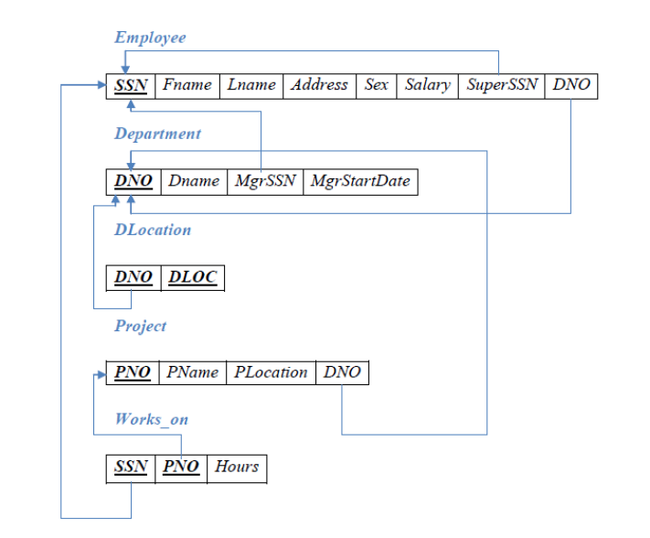

**Instructions:**

1. Do and write programs with proper naming conventions.
2. Practice all programs on your own. Copying the solution from others will be penalized.
3. Maintain index / content properly.
4. Brief descriptions including algorithm used and flowchart of the work you did for each exercise.
5. If you believe I have an error in a lab, please inform me of it. Explain why you think it is an error and, if you like, suggest a correction.
6. Perform unit testing with prepared test cases.
7. Save the programs in a separate folder on PC (in Lab), and push it in your Git repo.

|  |  |  |
| --- | --- | --- |
| SL No | Question | Concepts Covered |
| 1. | Develop SQL Queries to execute and verify the Data Definition Language commands and also implement Data Constraints.   1. Create five tables using constraints like primary key, not null, check, default, null, unique, foreign key as per the above schema 2. Add another column Age with datatype integer in employee table 3. Drop a table named Project 4. Truncate a table named Works_on 5. View the structure of the table Department | DDL commands- CREATE, ALTER,DROP,TRUNCATE and DESC  Data Constraints- primary key, foreign key, check, unique, not null, null, default |
| 2. | Develop SQL Queries to execute and verify the Data Manipulation Language commands.   1. Insert five records in the tables as per the above schema 2. Display the entire content of the tables as per the above schema 3. Modify the salary of the employee as 25000 whose SSN is e1001 4. Delete the details of the employee whose SSN is e1002 | DML Commands- INSERT, SELECT, UPDATE and DELETE |
| 3. | Develop SQL Queries to implement Data Control Language commands   1. To grant a SELECT permission on employee table to user1 2. Revoking a privilege to all users in a table | DCL Commands- GRANT, REVOKE |
| 4. | Develop SQL Queries to execute computation on table data with built-in functions  Group functions   1. List the fname of all the employee having ‘a’ as the second last character in their name. 2. Count the total number of male and female employees in the Employee table. 3. Calculate the average salary of the female employees. 4. Calculate the sum of salaries of male employees. 5. Display the maximum and minimum salaries of male employees. 6. Display the details of all employees whose salary between 25000 and 50000 7. Display the lname of the employees whose salaries are 30000 or 40000 or 50000. | Group function /Aggregate function- **avg, max, min, sum, count**  group by clause, having clause  in/ not in, any, between/ not between, like/ not like |
| 5. | Develop SQL Queries to implement Nested Queries/ Sub Queries and Joins   1. Update the salary by 0.25 times for all the employees whose Plocation is ‘Chennai’. 2. To display the name and project location of employees whose working hour is greater than 5 3. Left join employee table and works_on table 4. Right join works_on table and employee table 5. Full join works_on table and employee table | Nested queries  Joins- Natural join, Inner join, Left Outer join, Right Outer join, Full join, Equi join |

**M.Sc. (Five Year Integrated) in Computer Science**

**(Artificial Intelligence & Data Science)**

**Semester 3**

**Database Systems Lab**

**LAB CYCLE 2**

**Instructions:**

1. Do and write programs with proper naming conventions.
2. Practice all programs on your own. Copying the solution from others will be penalized.
3. Maintain index / content properly.
4. Brief descriptions including algorithm used and flowchart of the work you did for each exercise.
5. If you believe I have an error in a lab, please inform me of it. Explain why you think it is an error and, if you like, suggest a correction.
6. Perform unit testing with prepared test cases.
7. Save the programs in a separate folder on PC (in Lab), and push it in your Git repo.

|  |  |  |
| --- | --- | --- |
| SL No | Question | Concepts Covered |
| 1. | Develop SQL Queries for creating and dropping Views   1. Create a view VW_emp on employee table 2. Create another view VW_SSN contains SuperSSN and Dno of female employees 3. Update the address of employee to Chennai whose id is e100 in view VW_emp 4. Delete the view VW_emp | Views- creating views, updating views, dropping views |
| 2. | Develop PL/SQL program to familiarize with Function and Procedure   1. Write a PL/SQL function to find factorial of a number 2. Write a PL/SQL function to find maximum of two numbers 3. Write a PL/SQL procedure to find whether a given number is prime or not 4. Write a PL/SQL procedure to display numbers from 1 to 10 using while loop | Functions And Procedures |
| 2. | Develop PL/SQL program to implement Cursor   1. Write a PL/SQL cursor program to update the salary of each employee of department number D001 in the Employee table as per the schema 2. Write a PL/SQL cursor program to retrieve Dno and DName from Department table as per the schema | Cursor |
| 3. | Develop and execute a Trigger before and after Update/Delete/Insert operations on a table   1. Write PL/SQL trigger program to display the salary differences between the old values and new values in the table employee as per the schema 2. Write PL/SQL trigger program to display the hour differences between the old values and new values in the table Works_on as per the schema | Trigger |
| 4. | Develop SQL Queries to understand the concept of Transaction Control Language   1. Creating Check points in the program 2. Rollback to a previously created Checkpoint in the program 3. Commit the program | TCL Commands- COMMIT, ROLLBACK, CHECK POINTS |
| 5. | Develop program to perform operations in MongoDB   1. Create a database emp 2. Create new Collection 3. Check the collection list created and drop collection 4. Insert document in selected Collection 5. To get the list documents in Collection 6. Update the document in Collection 7. Save the document in Collection 8. Delete the document in selected Collection 9. Projection using find() method 10. Drop database emp | NOSQL Systems  MongoDB- insert, query, update, delete, projection |
| 6. | Develop a GraphQL program to perform different operations in created ontology | Simple Structure of GraphQL program |
| 7. | Develop program to implement Java Database Connectivity   1. Write a program which connects to an online book database and insert the details of the books in to the database 2. Write a program which connects to an online Employee database and retrieve the details of the employees in the database as per the schema 3. Write a program which connects to an online hospital database and update the details of the patients in the database 4. Write a program which connects to an online Hotel database and delete the details of the orders from the database | Java Database Connectivity |

**M.Sc. (Five Year Integrated) in Computer Science**

**(Artificial Intelligence & Data Science)**

**Semester 3**

**Database Systems Lab**

**LAB CYCLE 3**

**Instructions:**

1. Do and write programs with proper naming conventions.
2. Practice all programs on your own. Copying the solution from others will be penalized.
3. Maintain index / content properly.
4. Brief descriptions including algorithm used and flowchart of the work you did for each exercise.
5. If you believe I have an error in a lab, please inform me of it. Explain why you think it is an error and, if you like, suggest a correction.
6. Perform unit testing with prepared test cases.
7. Save the programs in a separate folder on PC (in Lab), and push it in your Git repo.

|  |  |  |
| --- | --- | --- |
| SL No | Question | Concepts Covered |
| 1. | Develop a mini project based on Java Database Connectivity  Front end- Java/Swing  Back end- MySQL  IDE- NetBeans IDE | Java Database Connectivity |